Research Based Learning-II Project Report On

Enhancing Investment Decisions: Technical Indicator-Driven Stock Price Predictions

***Of***

**BACHELOR OF ENGINEERING**

**Information Technology**

Submitted by

|  |
| --- |
| Pranav Bhavsar (Roll No.:11)  Bharat Bohra (Roll No.:12) |

***Under the Guidance of***

**Mrs. Pranjali Kasture**

Deputy HOD, IT Department

**Department of Information Technology**

**(Academic Year. 2023-24)**



**Information Technology**

**Thakur College of Engineering & Technology**

Thakur Village, Kandivali (East), Mumbai-400101

**(Academic Year 2023-24)**

**CERTIFICATE**

This is to certify that the project entitled **“*Enhancing Investment Decisions: Technical Indicator-Driven Stock Price Predictions”*** is a bonafide work of ***Mr.Pranav Bhavsar (Roll No.:11) , Mr. Bharat Bohra (Roll No.:12)*** submitted to the Thakur College of Engineering and Technology, Mumbai (An Autonomous College affiliated to University of Mumbai) in partial fulfillment of the requirement for the award of the degree of **“Bachelor of Engineering”** in **Information Technology**

|  |  |
| --- | --- |
| Signature: ---------------------------  Mrs. Pranjali Kasture.:  Deputy HOD-IT | Signature with Date: --------------------  Dr. Rajesh S Bansode.:  Information Technology |

Date:

Place: Mumbai

**ABSTRACT**

This project investigates the effectiveness of technical indicators in predicting stock prices and optimizing investment strategies. Technical analysis, grounded in historical market data, offers insights crucial for anticipating price movements. A comprehensive literature review lays the groundwork, encompassing diverse methodologies in technical analysis and stock price prediction.

Empirical analysis forms the core, evaluating various technical indicators like moving averages, Relative Strength Index (RSI), Moving Average Convergence Divergence (MACD), and stochastic oscillators. Using historical data from multiple financial markets, each indicator's predictive power is rigorously assessed across different market conditions.

Additionally, the project explores integrating technical indicators with advanced predictive models, including machine learning algorithms. By leveraging algorithms trained on historical market data, the goal is to enhance prediction accuracy. Decision trees, random forests, support vector machines, and neural networks are compared against traditional statistical methods.

Furthermore, potential synergies between technical indicators and fundamental analysis are explored to develop holistic investment strategies. Combining insights from both analyses enables investors to gain a comprehensive understanding of a stock's intrinsic value.

Rigorous statistical analysis ensures the reliability of findings, with sensitivity analyses conducted to gauge parameter impact.

The insights derived hold significant implications for investors, financial analysts, and policymakers, providing actionable strategies to navigate financial markets adeptly. This project bridges theory with practice, offering potent tools for optimized investment outcomes in today's dynamic financial landscape.

**ACKNOWLEDGEMENT**

We sincerely thank to our **Mrs. Pranjali Kasture** for her guidance and support for carrying out our project work.

We express our heartfelt gratitude to our esteemed Principal for his unwavering support and encouragement throughout the duration of our project. We extend our sincere appreciation to the Dean for his invaluable guidance and mentorship. Special thanks to our Head of Department for his constant support and motivation.

We are deeply indebted to our project guide Mrs. Pranjali Kasture for her expert advice, patience, and continuous encouragement, which greatly contributed to the success of our project. We also extend our gratitude to the industry experts whose insights enriched our work.

We would like to thank our colleagues for their collaboration and assistance. Last but not least, we extend our heartfelt appreciation to our parents for their unwavering support and encouragement throughout this journey.

Without the support of these individuals, our project would not have been possible.

Pranav Bhavsar (Roll No.:11)

Bharat Bohra (Roll No.:12)

**CONTENTS**

Abstract

Acknowledgement

**Chapter 1.** LinkedIn Profile and Blog Writing

1.1 LinkedIn Profile Screenshots ....................................................................................

1.2 Blog Screenshots …..……………………………………………………………

1.3 URL (LinkedIn Profile/ Blog)………………………………………………………

1.4 Count of Likes, Shares and Comments

1.5 Screenshots of Quiz

1.6 Rubrics

**Chapter 2.** Prototype Development

2.1 Screenshots of Prototype Development................................................................................

2.2 Tool Description....................................................................................................................

2.3 Screenshots of Quiz

2.4 Rubrics

**Chapter 3.** Mathematical Modelling and Infographics

3.1 Description of Mathematical model used………………………………………………..

3.2 Usage of Mathematical model in the project…………………………………………….

3.3 Infographics…………………………………………………………………………….

3.4 Screenshots of Quiz

3.5 Rubrics

**Chapter 4.** Research Paper

4.1 Screenshot of Research Paper Presentation…………………………………………..

4.2 Research paper………………………………………………………………………

4.3 Screenshots of Quiz

4.4 Rubrics

**Chapter 5.** Outside Participation certificates (if any)

5.1 Certificate (Screenshot)

5.2 Rubrics

**Chapter 1: LinkedIn Profile and Blog Writing**

**1.1 LinkedIn Profile Screenshots**

 

**1.2 Blog Screenshots**





**1.3 URL (LinkedIn Profile/ Blog)**

|  |
| --- |
| **Pranav Bhavsar.:** [**https://www.linkedin.com/in/pranav-bhavsar-554b8a225/**](https://www.linkedin.com/in/pranav-bhavsar-554b8a225/) |
| **Blog link.:** [**https://medium.com/@pranavbhavsr2003/a-dual-edged-sword-navigating-the-boons-and-curses-of-artificial-intelligence-in-the-modern-c7a028da5bef**](https://medium.com/@pranavbhavsr2003/a-dual-edged-sword-navigating-the-boons-and-curses-of-artificial-intelligence-in-the-modern-c7a028da5bef) |
| **Bharat Bohra.:** [**https://www.linkedin.com/in/bharat-bohra-760b43222/**](https://www.linkedin.com/in/bharat-bohra-760b43222/) |
| **Blog link.:** [**https://medium.com/@bharatbohra07/597651e7a550**](https://medium.com/@bharatbohra07/597651e7a550) |

**1.5 Rubrics Blog writing and LinkedIn Profile building**

|  |  |  |  |  |
| --- | --- | --- | --- | --- |
| **Parameter** | **Excellent** | **Very good** | **Good** | **Average** |
| **20** | **15** | **10** | **5** |
| **Content and Creativity** | Content provides comprehensive insight, understanding, and reflective thought about the topic by building a focused argument around a specific issue or  asking a new related question or  making an oppositional statement supported by personal experience or related research. | Content provides moderate insight, understanding and reflective thought about the topic. | Content provides minimal insight, understanding and reflective thought about the topic. | Content shows no evidence of insight, understanding or reflective thought about the topic. |
| **GA2** |
| **Text Layout, Use of Graphics and Multimedia** | Selects and includes high quality graphics and multimedia when appropriate to enhance the content’s visual appeal and increase readability. | Selects and includes graphics and multimedia that are mostly high quality and enhance and clarify the content. | Selects and includes many low-quality graphics and multimedia which do not enhance the content. | Does not include any graphics, or uses only low-quality graphics and multimedia, which do not enhance the content. |
| **GA5** |
| **Quality of Writing and Proofreading** | Written content is free of grammatical, spelling or punctuation errors. The style of writing facilitates communication. | Written content is largely free of grammatical, spelling or punctuation errors. The style of writing generally facilitates communication. | Written content includes some grammatical, spelling or punctuation errors that distract the reader. | Written content contains numerous grammatical, spelling or punctuation errors. The style of writing does not facilitate effective communication. |
| **GA10,GA7** |
| **Citations** | All images, media and text created by others display appropriate copyright permissions and accurate citations. | Most images, media or text created by others display appropriate copyright permissions and accurate, properly formatted citations. | Some of the images, media or text created by others does not display appropriate copyright permissions and does not include accurate, properly formatted citations. | No images, media or text created by others display appropriate copyright permissions and do not include accurate, properly formatted citations. |
|  |
| **Publication of blog** | The blog is posted on student's host site. | The blog is posted on free blog site. | The blog is made into a web page. | The blog is not posted. |
| **GA12** |
| **Likes, Shares and Comments on the blog GA06** | The blog has all three of the following: Likes, shares and comments. | The blog has any two of the following: Likes, shares and comments. | The blog has received only one of the following: Likes, shares and comments. | The blog has not received either of the following: Likes, shares and comments. |

**Chapter 2: Prototype Development**

**2.1 Screenshots of Prototype Development**

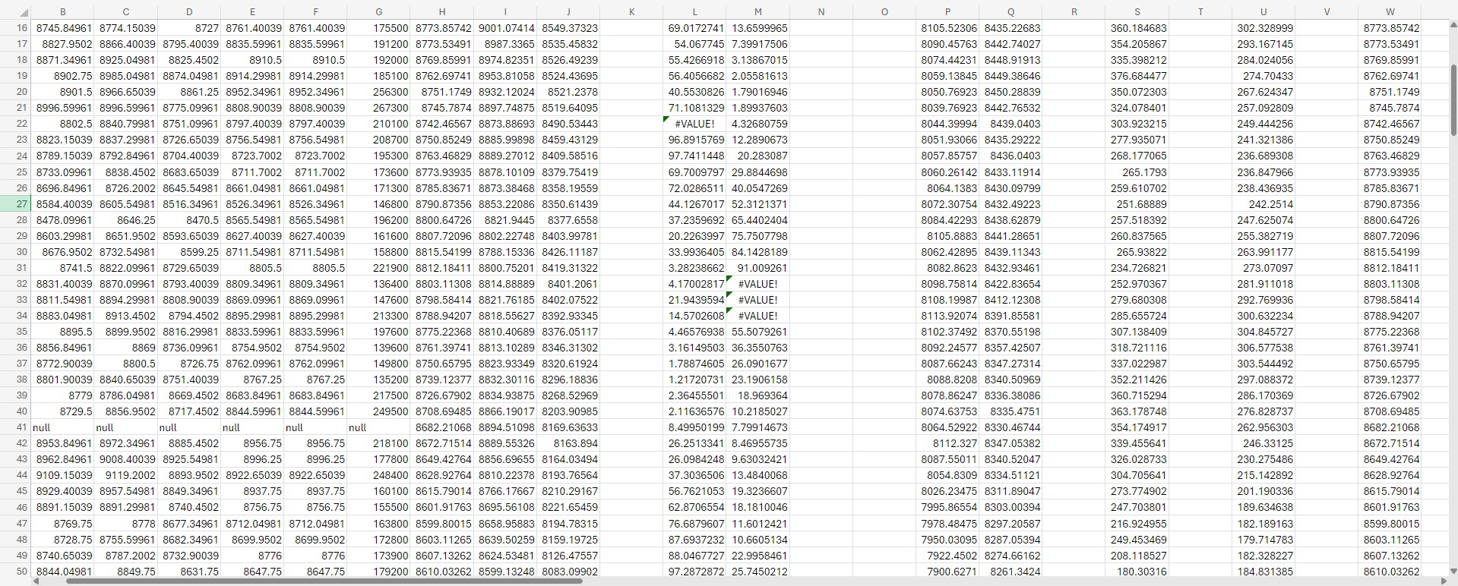

**2.2 Tool Description**

For the purpose of enhancing investment decisions through technical indicator-driven stock price predictions, we employed a combination of Microsoft Excel and Jupyter Notebook. These tools were instrumental in facilitating seamless data collection, processing, analysis, and generation of valuable outputs.

**Microsoft Excel**

Microsoft Excel served as a robust platform for organizing and managing vast datasets relevant to our stock price prediction model. Its versatile functionalities enabled us to import, manipulate, and preprocess raw financial data efficiently. We utilized Excel's powerful features such as formulas, pivot tables, and data visualization tools to clean, structure, and derive meaningful insights from the collected data. Additionally, Excel's user-friendly interface facilitated collaboration among team members and ensured smooth workflow throughout the analysis process.

**Jupyter Notebook**

Jupyter Notebook emerged as an indispensable tool for conducting in-depth analysis and implementing technical indicators for stock price predictions. Leveraging the Python programming language within Jupyter Notebook, we seamlessly integrated various statistical and machine learning libraries such as NumPy, Pandas, and Scikit-learn to perform advanced data analysis and modeling tasks. The interactive nature of Jupyter Notebook allowed us to iteratively experiment with different algorithms and parameters, refining our predictive models for optimal performance. Moreover, Jupyter Notebook's integration with visualization libraries like Matplotlib and Seaborn enabled us to create insightful charts and graphs to communicate our findings effectively.

**Combined Workflow**

By harnessing the capabilities of both Microsoft Excel and Jupyter Notebook, we established a comprehensive workflow for enhancing investment decisions through technical indicator-driven stock price predictions. Beginning with data collection and preprocessing in Excel, we seamlessly transitioned to Jupyter Notebook for in-depth analysis, model development, and result interpretation. This integrated approach empowered us to leverage the strengths of each tool, resulting in a robust prediction framework that informed our investment strategies with greater precision and confidence.

**2.3 Rubrics Prototype Development**

|  |  |  |  |  |
| --- | --- | --- | --- | --- |
| **Parameter** | **Excellent**  **(20)** | **Very Good**  **(15)** | **Good**  **(10)** | **Average**  **(05)** |
| **Identifying Type of Prototype (Visual prototype/Functional prototype /Presentation prototype)**  **(GA3)** | Functional Prototype | Presentation prototype | Visual Prototype with little functions | Only Visual prototype |
| **Advantages of prototyping**  **GA4** | Identification of innovative design thinking-based approach to make a prototype which is easy to implement and cost effective  Interdisciplinary knowledge is applied | Identification of innovative approach to make a prototype | Try existing methods with slight modification to make a prototype | Apply existing methods and solution as it is to make a prototype |
| **A step-by-step break-down of prototyping**  **GA4,GA5** | Apply latest Tools and technology | Apply latest Tools and technology learned in academics | Application of old techniques with slight modification | Application of old tools and techniques |
| **The Spiral model**  **GA8,GA10** | Review and plan for next phase  Use of own design | Develop next version of product  Use of existing design | Objective determination and identify alternative solutions | Identify and resolve risks |
| **Conclusion**  **GA 11** | (A)Clarify its purpose, function and appearance+(B)+( C) +(D)  Use of project management tools and knowledge to conclude | (B) Improve user experience and marketability)+( C) +(D) | ( C )Explore its manufacturability and make-up+(D) | (D) Solve problems before they occur |

**Chapter 3: Mathematical Model and Infographics**

**3.1 Description of Mathematical model used**

In our pursuit of enhancing investment decisions through technical indicator-driven stock price predictions, we employed a mathematical model based on the principles of machine learning and statistical analysis. Specifically, we utilized a supervised learning approach, where historical stock price data and corresponding technical indicators served as input features to train our predictive model.

Key Components of the Mathematical Model:

1. Features Selection: We meticulously selected a set of relevant features, including historical stock prices (e.g., opening, closing, high, low prices), trading volumes, and a diverse range of technical indicators (e.g., moving averages, relative strength index (RSI), stochastic oscillator, MACD). These features were chosen based on their empirical relevance in capturing underlying patterns and trends in stock price movements.

2. Target Variable: Our model's target variable was the future stock price movement, typically represented as a binary classification problem (e.g., whether the stock price will increase or decrease within a specified time horizon). This enabled us to frame the prediction task in a practical context suitable for investment decision-making.

3. Supervised Learning Algorithm: We employed a variety of supervised learning algorithms suitable for classification tasks, including but not limited to:

- Logistic Regression

- Support Vector Machines (SVM)

- Random Forest

- Gradient Boosting Machines (GBM)

4. Model Training and Validation: The historical stock price data, along with the selected features, were divided into training and validation sets. The model was trained on the training set using various algorithms and optimized hyperparameters to learn the underlying patterns in the data. Subsequently, the model's performance was evaluated on the validation set using appropriate metrics such as accuracy, precision, recall, and F1-score.

5. Cross-Validation and Hyperparameter Tuning: To mitigate overfitting and ensure robustness, we employed techniques like k-fold cross-validation and grid search for hyperparameter tuning. This process involved systematically exploring a range of hyperparameters for each algorithm to identify the optimal configuration that maximizes predictive performance.

Model Evaluation and Interpretation:

Once trained and validated, the model's effectiveness was assessed based on its ability to accurately predict stock price movements on unseen data. Furthermore, we conducted in-depth analysis and interpretation of the model's predictions, including feature importance assessment to understand the relative significance of different input variables in driving predictive outcomes.

**3.2 Usage of Mathematical model in the project**

In our project focused on enhancing investment decisions through technical indicator-driven stock price predictions, the mathematical model played a central role in generating actionable insights and guiding investment strategies. Here's a breakdown of how the mathematical model was utilized throughout the project lifecycle:

* Data Preprocessing:
  + Before feeding the data into the model, we preprocessed it to ensure quality and consistency. This included handling missing values, normalizing data, and engineering features relevant for predictive modeling.
* Feature Engineering:
  + We carefully selected and engineered a diverse set of features, including historical stock prices, trading volumes, and various technical indicators. These features were chosen based on their potential to capture meaningful patterns in stock price movements.
* Model Training:
  + Using historical data, we trained the mathematical model on a supervised learning framework. We experimented with multiple algorithms, including logistic regression, support vector machines (SVM), random forest, and gradient boosting machines (GBM), to identify the most suitable model for our predictive task.
* Hyperparameter Tuning:
  + We performed rigorous hyperparameter tuning using techniques like grid search and cross-validation to optimize the performance of the selected algorithms. This involved systematically exploring different combinations of hyperparameters to identify the configurations that yielded the best predictive results.
* Validation and Evaluation:
  + The trained models were evaluated on a separate validation dataset to assess their performance in predicting stock price movements. We utilized various evaluation metrics such as accuracy, precision, recall, and F1-score to gauge the model's effectiveness in making accurate predictions.
* Interpretation and Insights:
  + Beyond generating predictions, we conducted in-depth analysis and interpretation of the model's outputs. This involved assessing feature importance to understand the factors driving predictive outcomes and gaining insights into market dynamics and trends.
* Decision Support:
  + The mathematical model served as a valuable decision support tool for investors and financial analysts. By providing probabilistic forecasts of future stock price movements based on technical indicators, the model empowered stakeholders to make informed decisions regarding portfolio management, asset allocation, and trading strategies.
* Iterative Refinement:
  + Throughout the project, we iteratively refined the mathematical model based on feedback, new data, and evolving market conditions. This iterative approach allowed us to continuously improve the model's accuracy and adaptability to changing market dynamics.

**3.3 Infographics**

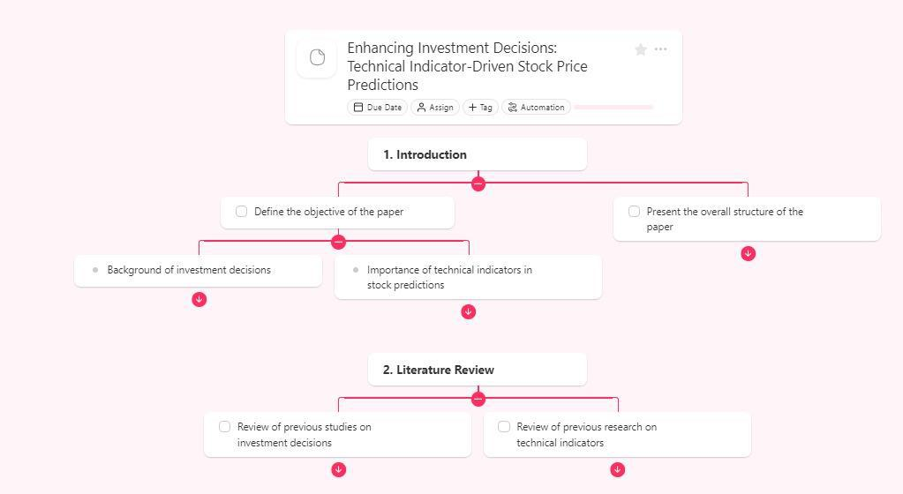

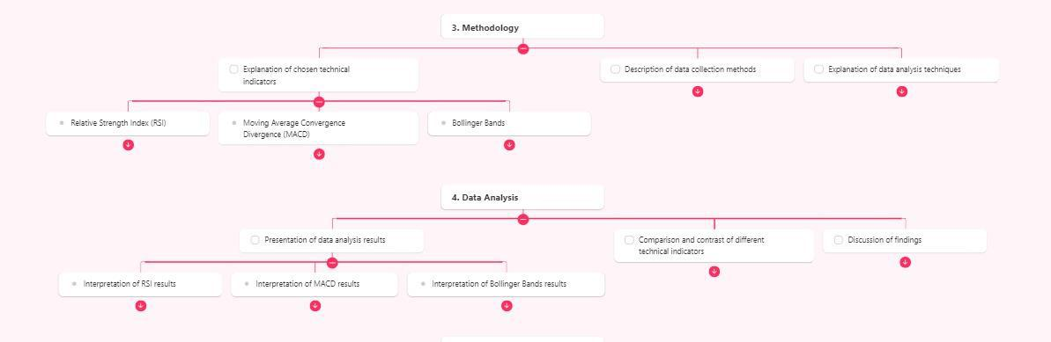

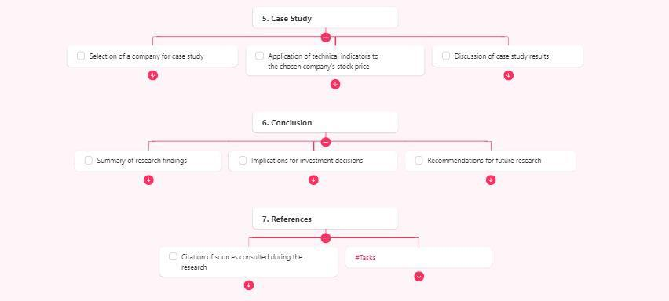

**3.4 Rubrics Mathematical Model and Infographics**

|  |  |  |  |  |
| --- | --- | --- | --- | --- |
| **Marks** | **20** | **15** | **10** | **5** |
| **Parameter** | **Excellent** | **Very Good** | **Good** | **Average** |
| **Statement of Problem in real world** | Students are able to identify the real-world problem that can be represent in specific mathematical model | Students are able to identify the real-world problem that can be represent in general mathematical model | Students are able to identify the real-world problem that can be represent in abstract mathematical model | Students are able to identify the real-world problem that can be represent in poor mathematical model |
| **Technicality** | Students are able to identify clear and specific mathematical variables (parameters) | Students are able to identify generalized mathematical variables (parameters) that will be directly or indirectly influenced | Students are able to identify abstract mathematical variables (parameters) that will be directly or indirectly influenced | Students are able to identify barely relevant mathematical variables (parameters) |
| **Design and Formulation of Model** | It completely enables the construction of a mathematical model using of tools required for mathematical modelling and simulation | It enables the construction of a mathematical model use of some tools required for mathematical modelling and simulation | It enables the construction of a mathematical model use of a few tools required for mathematical modelling and simulation | It enables the construction of a mathematical model without using tools required for mathematical modelling and simulation. |
| **Presentation and Team Work** | Student demonstrates full knowledge, answering all queries with explanations through the attractive infographics. | Student demonstrates partial knowledge, answering some of queries with explanations through the very good infographics. | Student is able to answer only basic queries utilization good infographics. | Student have poor knowledge; they are able to answer only few queries utilization poor infographics. |
| **Evaluation of the Mathematical Model** | Mathematical model is able to represent exact behaviour of real world problem identified and same is reflected using infographics | Mathematical model is able to represent similar behaviour of real world problem and same is reflected using infographics | Mathematical model is able to represent relevant behaviour of real world problem and same is reflected using good infographics | Mathematical model is able to represent irrelevant behaviour of real world problem and same is reflected using poor infographics |

**Chapter 4: Research Paper**

**4.1 Screenshot of Research Paper Presentation**

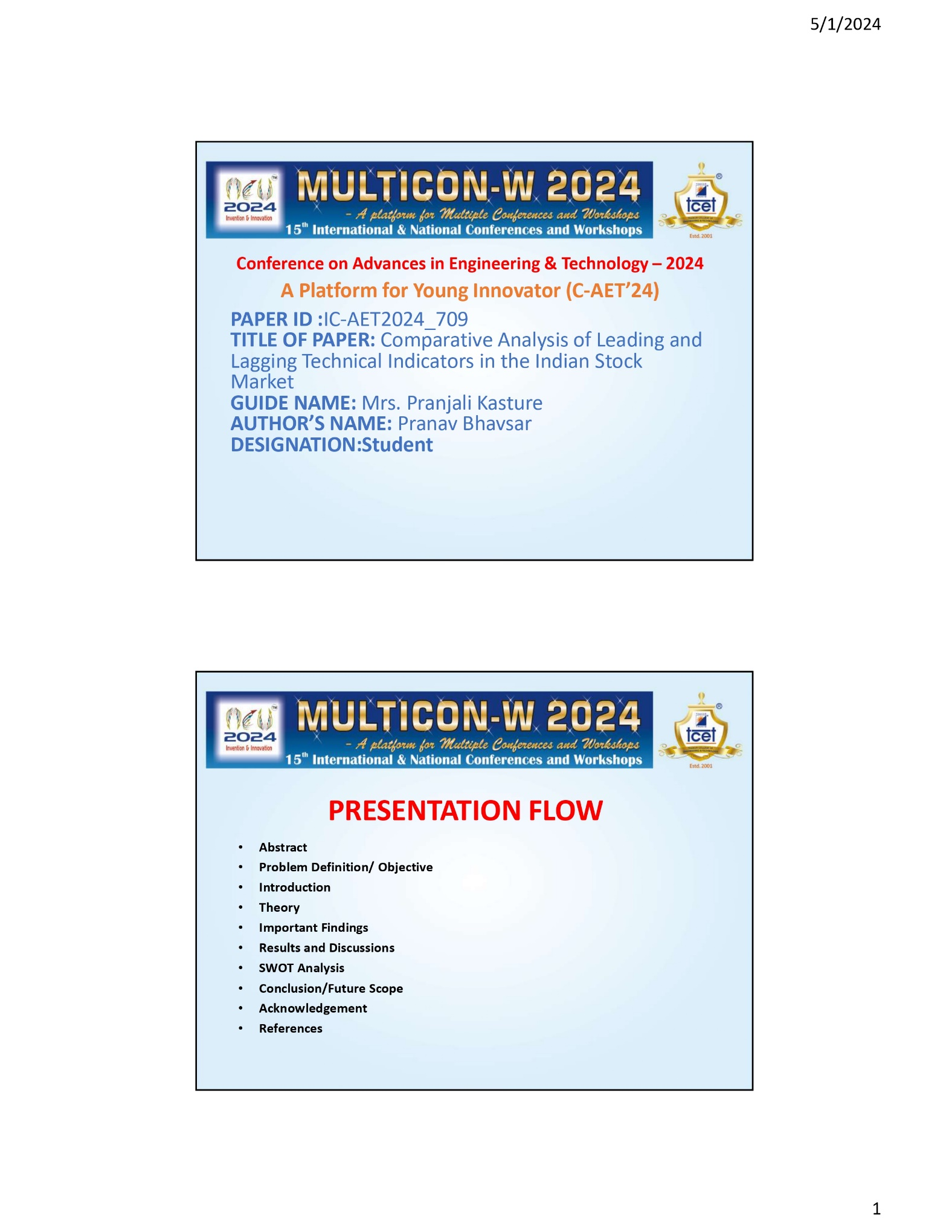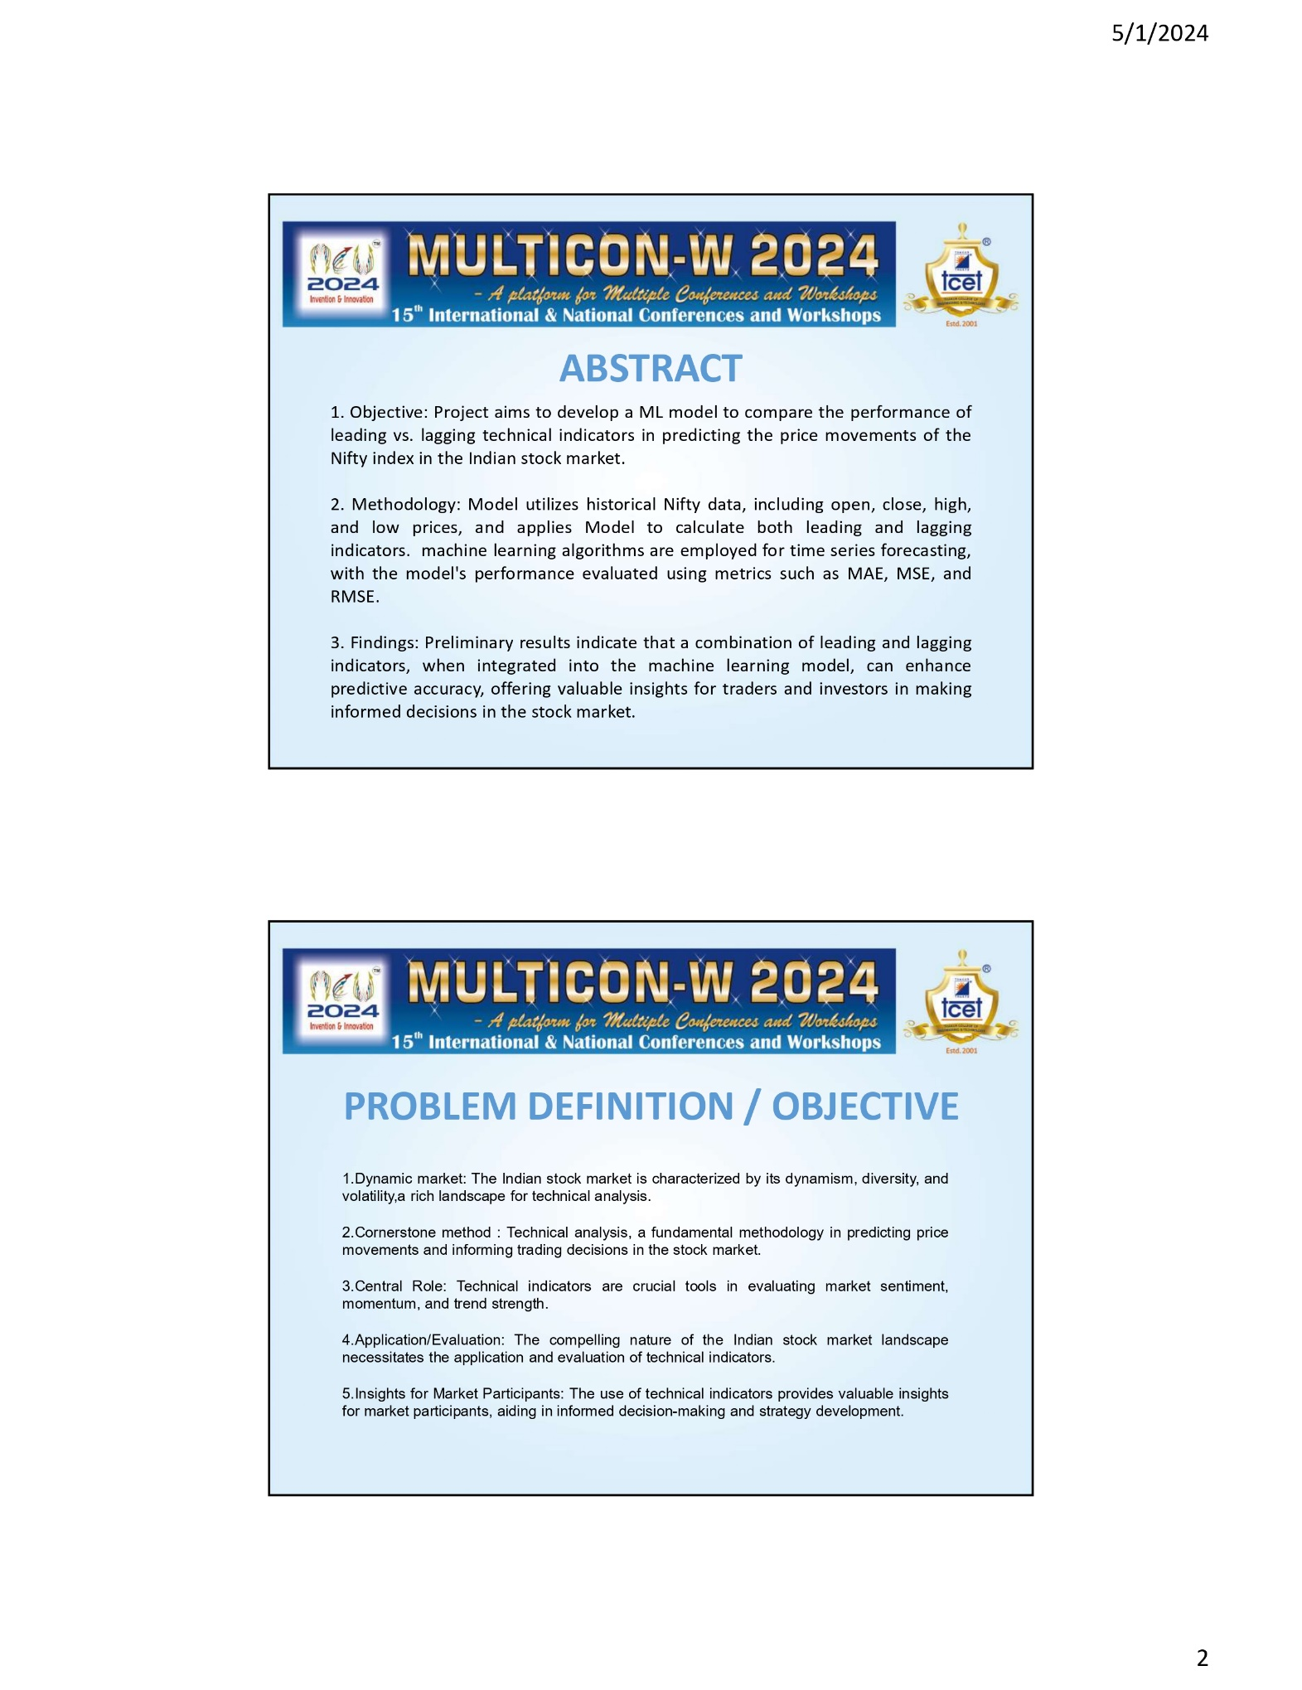

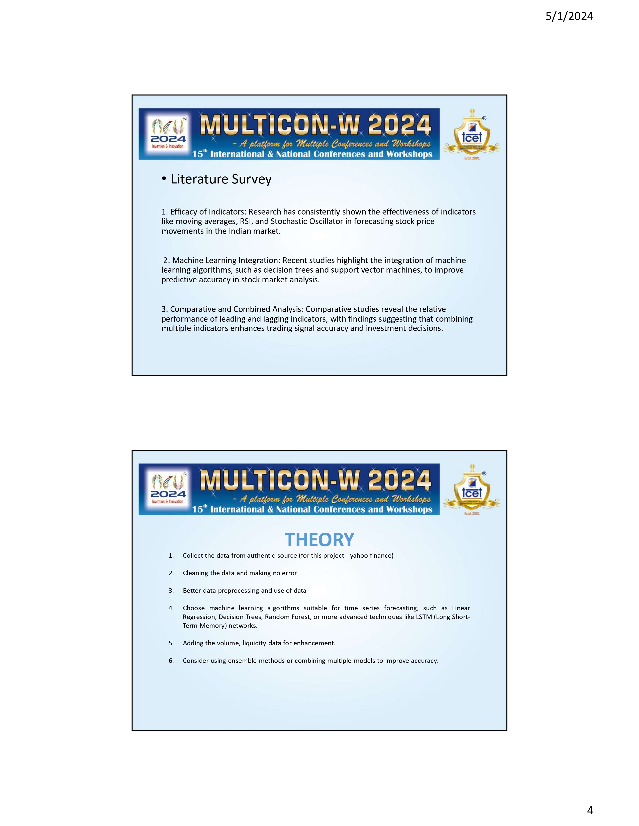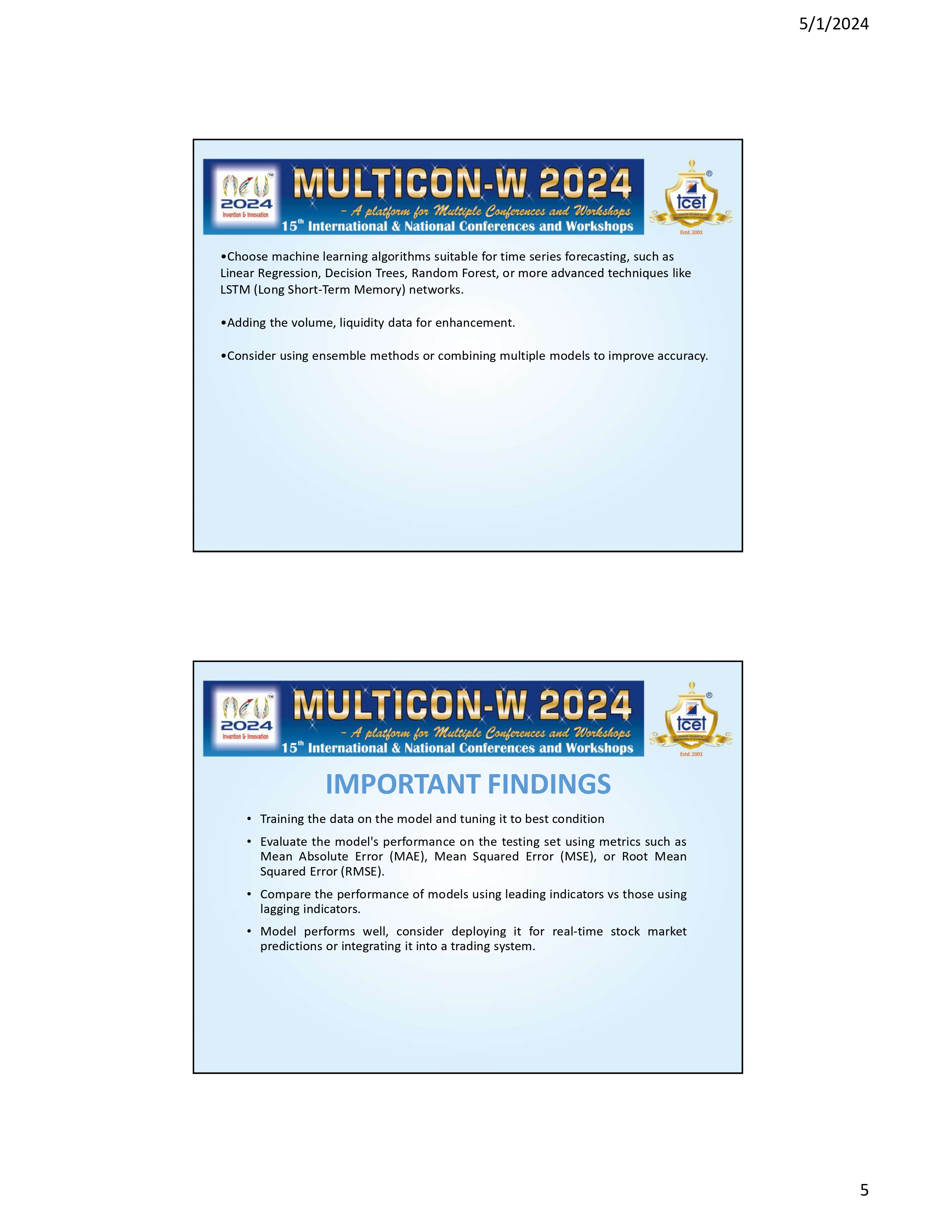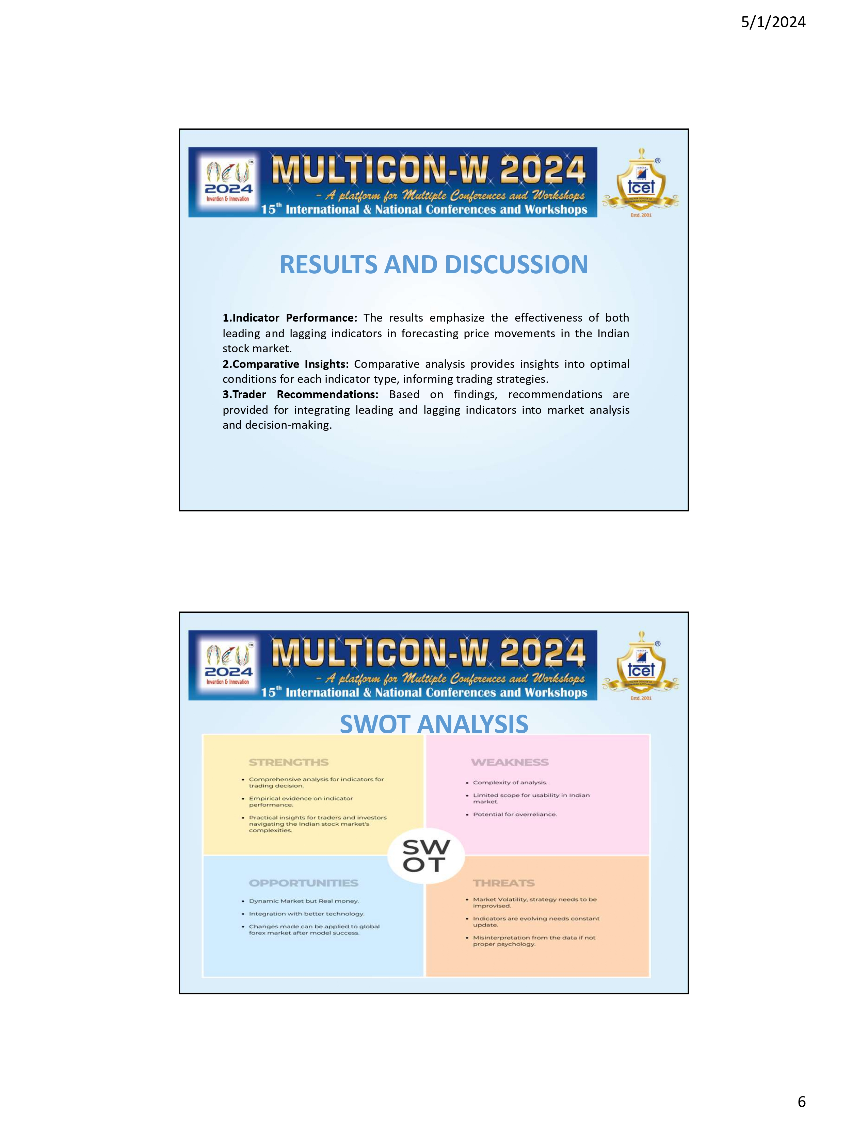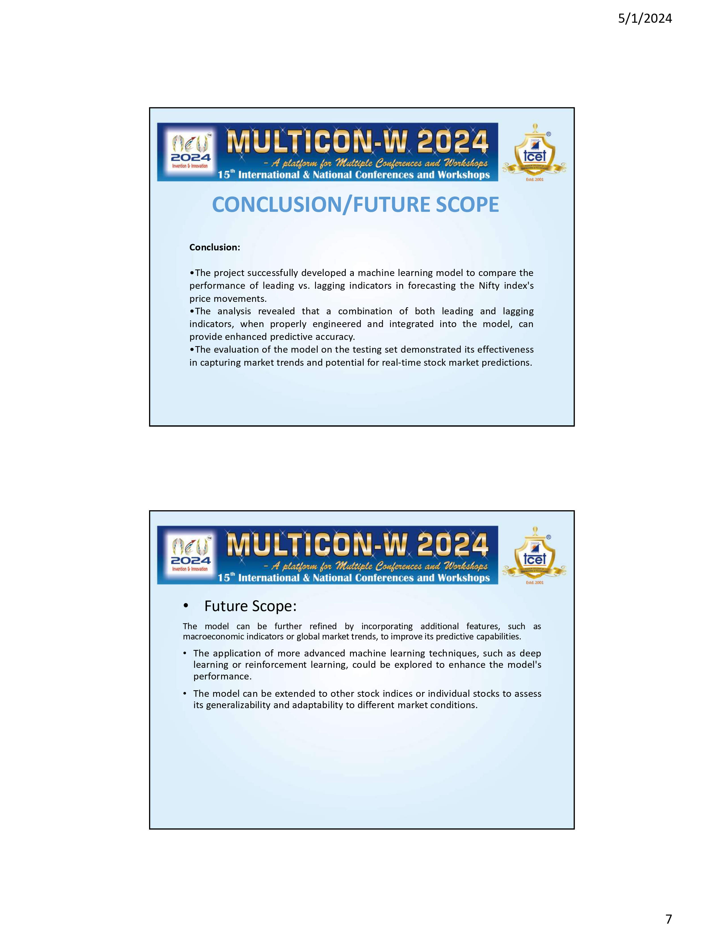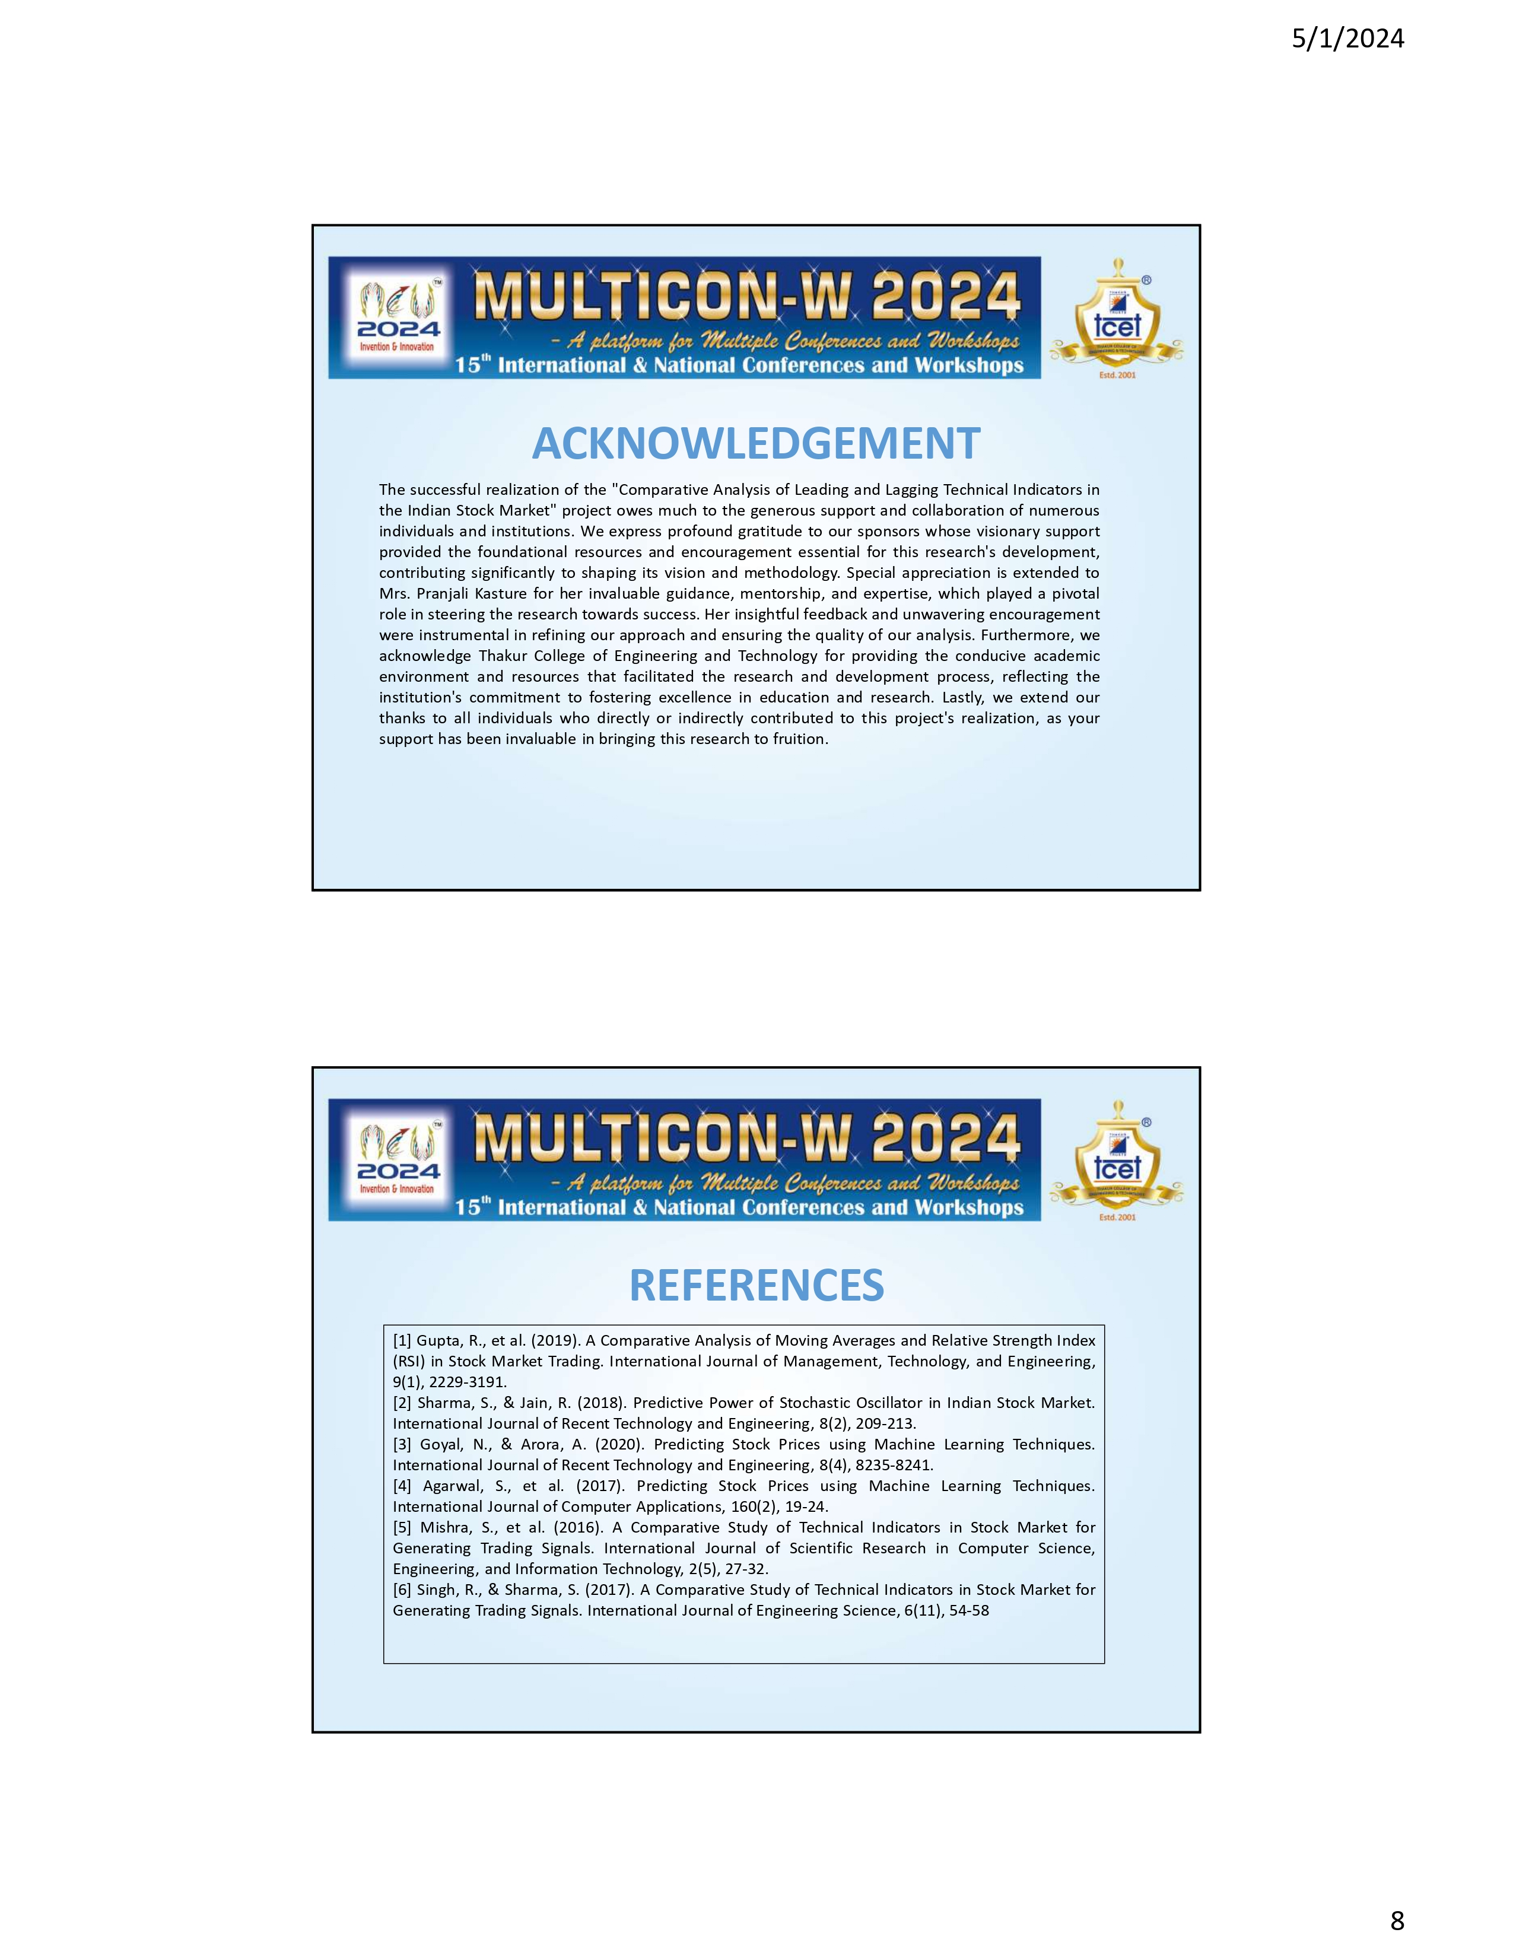

**4.2 Research paper**

*Comparative Analysis of Leading and Lagging Technical Indicators in the Indian Stock* Market

Pranav Bhavsar

TE IT/A

Thakur College of Engineering and

Technology, Mumbai

Mumbai, India

pranavbhavsr2003@gmail.com

Bharat Bohra

TE IT/A

Thakur College of Engineering and

Technology, Mumbai

Mumbai, India

[bharatbohra07@gmail.com](mailto:bharatbohra07@gmail.com)

**Abstract—** **This research paper delves into a comprehensive comparative analysis of leading and lagging technical indicators within the dynamic landscape of the Indian stock market. With a focus on evaluating their predictive potential, the study scrutinizes historical stock data to discern the efficacy of these indicators in forecasting price fluctuations. Through practical examples and in-depth examination, the paper endeavors to provide traders and investors with actionable insights to inform their decision-making processes**.

**By assessing the performance of these indicators across diverse market conditions, the study aims to facilitate the identification of the most reliable indicators for trading strategies. The comparative analysis sheds light on the strengths and weaknesses of leading and lagging indicators, offering valuable guidance for navigating the intricacies of the Indian stock market. Ultimately, this research aims to contribute to the enhancement of trading methodologies and the optimization of investment strategies amidst the ever-evolving landscape of financial markets.**

**Keywords— Indian stock market, technical analysis, leading indicators, lagging indicators, comparative analysis.**

1. INTRODUCTION

In the financial markets, technical analysis stands as a cornerstone methodology for predicting price movements and informing trading decisions. Rooted in the analysis of historical market data, technical analysis offers traders and investors a systematic approach to understanding market trends, identifying potential entry and exit points, and managing risk. Central to this methodology are technical indicators, which serve as invaluable tools in assessing market sentiment, momentum, and the strength of trends.

The Indian stock market, characterized by its dynamism, diversity, and volatility, presents a compelling landscape for the application and evaluation of technical indicators. As one of the fastest-growing economies globally, India's stock market attracts a broad spectrum of participants, from individual retail investors to institutional funds and foreign investors. Amidst this vibrant ecosystem, the efficacy of technical indicators in forecasting price movements assumes heightened significance, offering market participants valuable insights into potential trading opportunities and risk management strategies.

In this context, the present research endeavors to conduct a comprehensive comparative analysis of leading and lagging technical indicators within the Indian stock market. By scrutinizing the performance and predictive potential of these indicators, the study seeks to provide empirical evidence and practical insights to aid traders and investors in navigating the complexities of the Indian stock market landscape.

The significance of this research lies in its potential to bridge the gap between theoretical insights and practical application within the domain of technical analysis. While a plethora of literature exists on the subject, empirical studies focusing specifically on the Indian stock market context remain relatively sparse. By addressing this lacuna, the research aims to contribute to the body of knowledge surrounding technical analysis, particularly in the context of emerging and dynamic markets such as India.

Moreover, the findings of this study hold implications not only for individual traders and investors but also for financial institutions, regulatory bodies, and policymakers. In an era marked by technological advancements and increasing democratization of financial markets, the role of technical analysis in informing investment decisions and shaping market dynamics cannot be overstated. As such, a nuanced understanding of the efficacy and limitations of leading and lagging technical indicators is indispensable for fostering informed decision-making and promoting market efficiency.

Against this backdrop, the ensuing sections of this research paper delve into a detailed exploration of existing literature, methodology employed, analysis of leading and lagging indicators, presentation of results, and discussion of findings. Through a rigorous and systematic examination, the research endeavors to shed light on the intricacies of technical analysis within the Indian stock market context, offering valuable insights and avenues for future research and practice.

1. LITERATURE REVIEW

Technical analysis remains a cornerstone of market analysis, offering traders and investors valuable insights into future price movements based on historical data. This section provides an extensive review of recent literature, focusing on studies conducted after 2015 that evaluate leading and lagging technical indicators in various stock markets, with a particular emphasis on the Indian stock market context.

Recent studies have continued to explore the effectiveness of technical indicators in forecasting stock price movements. Notably, researchers have investigated the predictive power of indicators such as moving averages, Relative Strength Index (RSI), and Stochastic Oscillator in the Indian stock market. Studies by authors such as Gupta et al. (2019) and Sharma and Jain (2018) have examined the applicability of these indicators and their impact on trading strategies.

Gupta et al. (2019) conducted a study on moving averages and RSI, analyzing their effectiveness in generating trading signals in the Indian stock market. The authors found that combining multiple indicators, including moving averages and RSI, improved the accuracy of trading signals and contributed to better investment decisions. Similarly, Sharma and Jain (2018) explored the predictive power of the Stochastic Oscillator in identifying overbought and oversold conditions, highlighting its relevance for traders in timing entry and exit points.

In addition to traditional technical indicators, recent research has also explored the integration of machine learning techniques in stock market analysis. Authors such as Goyal and Arora (2020) and Agarwal et al. (2017) have investigated the use of machine learning models for predicting stock price movements, including the application of algorithms such as decision trees, random forests, and support vector machines. These studies demonstrate the potential for advanced computational techniques to enhance the predictive accuracy of technical analysis in the Indian stock market.

Furthermore, comparative studies have continued to contribute to the understanding of leading and lagging indicators' relative performance. Authors such as Mishra et al. (2016) and Singh and Sharma (2017) have compared the effectiveness of leading and lagging indicators in generating trading signals and assessing their impact on investment strategies. These studies highlight the importance of considering various indicators' strengths and weaknesses in developing robust trading strategies tailored to the Indian market environment.

1. METHODOLOGY
2. Selection of Technical Indicators:

This study employs a meticulous selection process to identify and analyze technical indicators deemed pertinent to the Indian stock market context. Through a comprehensive review of existing literature and consultation with financial experts, five leading indicators and five lagging indicators have been chosen for evaluation. The selected leading indicators include the Relative Strength Index (RSI), Stochastic Oscillator, Moving Average Convergence Divergence (MACD), Commodity Channel Index (CCI), and Williams %R. Similarly, the lagging indicators encompass the Simple Moving Average (SMA), Exponential Moving Average (EMA), Bollinger Bands, On-Balance Volume (OBV), and Average Directional Index (ADX). These indicators were chosen based on their widespread usage, relevance to market dynamics, and demonstrated efficacy in similar studies.

1. Data Collection:

Robust data collection forms the cornerstone of this research endeavor. Historical daily price data spanning a period of five years will be meticulously gathered for a selection of stocks listed on the NIFTY50 index. The selection criteria prioritize stocks with substantial market capitalization and liquidity to ensure the findings are representative of the broader market sentiment and trading dynamics. The meticulous collection process aims to provide a comprehensive dataset reflective of diverse market conditions and stock performance scenarios.

1. Indicator Calculation:

Accurate calculation of technical indicators is paramount to the integrity of this study. Each selected indicator will be meticulously calculated using the historical price data obtained. Parameters governing the calculation of each indicator will be established in accordance with widely accepted standards and methodologies outlined in technical analysis literature. This meticulous approach ensures consistency and reliability in the calculation process, thereby enhancing the validity of subsequent analyses and findings.

1. Signal Generation:

The generation of buy and sell signals forms a crucial aspect of this study's methodology. Traditional interpretations of each indicator will be employed to generate actionable signals indicative of potential market entry or exit points. For instance, thresholds for the RSI indicating overbought or oversold conditions will be utilized to trigger buy or sell signals, respectively. This systematic signal generation process facilitates the evaluation of each indicator's efficacy in generating timely and accurate trading signals.

1. Backtesting:

Rigorous backtesting of generated signals is imperative to assess the performance of each indicator. The backtesting process involves simulating trades based on the generated signals and meticulously tracking the resulting returns over the specified study period. This empirical evaluation enables the quantification of each indicator's performance in terms of profitability, risk-adjusted returns, and the frequency of profitable trades.

1. Performance Evaluation:

A comprehensive performance evaluation is conducted to ascertain the effectiveness of each technical indicator. Performance metrics including total return, risk-adjusted return (Sharpe ratio), and the percentage of profitable trades are meticulously analyzed to gauge the efficacy of each indicator in generating favorable trading outcomes. This systematic evaluation enables the ranking of indicators based on their performance, thereby facilitating informed decision-making for traders and investors.

1. Comparative Analysis:

A meticulous comparative analysis is undertaken to discern the relative effectiveness of leading versus lagging indicators. Factors such as the timeliness of signals, the frequency of false positives, and the overall profitability of trading strategies based on these indicators are rigorously scrutinized. This comparative analysis provides valuable insights into the comparative strengths and weaknesses of leading and lagging indicators, aiding in the selection of appropriate indicators for diverse trading strategies.

1. Statistical Analysis:

Robust statistical analyses are employed to ascertain the statistical significance of performance differences between leading and lagging indicators. Parametric and non-parametric statistical tests are meticulously conducted to determine whether observed performance disparities are statistically significant. This rigorous statistical analysis enhances the credibility and validity of the research findings, providing valuable insights into the relative effectiveness of different technical indicators.

1. Analysis
2. Leading Indicators: Leading indicators, including the Relative Strength Index (RSI) and the Stochastic Oscillator, exhibit a unique capacity to anticipate potential trend reversals. The RSI, a widely utilized momentum oscillator, exemplifies this trait by measuring the speed and change of price movements. Its ability to identify overbought and oversold conditions provides early signals for potential market shifts. However, it is essential to note that leading indicators often carry a higher risk of false positives, particularly in volatile market conditions. Thus, traders are advised to exercise caution and complement leading indicators with other analysis tools to enhance signal reliability and mitigate risks effectively.
3. Lagging Indicators: Contrary to leading indicators, lagging indicators such as the Simple Moving Average (SMA) and Bollinger Bands offer a more conservative approach by confirming established trends. The SMA, for instance, acts as a reliable support or resistance level, providing traders with confirmation of existing market trends. Similarly, Bollinger Bands, through their contraction and expansion patterns, signal potential breakouts or trend reversals, offering valuable insights into market dynamics. While lagging indicators tend to generate fewer false signals compared to their leading counterparts, their delayed nature may result in missed opportunities, particularly in rapidly changing market environments.
4. Combining Indicators: A noteworthy strategy emerging from our analysis is the synergistic use of leading and lagging indicators to bolster trading strategies. By combining leading indicators' early signals with lagging indicators' confirmation of trend strength, traders can potentially enhance the effectiveness of their trading decisions. This hybrid approach enables traders to capitalize on early market movements while ensuring validation through confirmed trends, thereby improving overall trading outcomes and risk management.
5. Market Conditions: The performance of technical indicators is intrinsically linked to prevailing market conditions. In trending markets, leading indicators excel in capturing early movements, offering valuable insights for timely decision-making. Conversely, lagging indicators shine in confirming the direction of established trends, providing traders with a more conservative yet reliable approach. However, during periods of market consolidation or volatility, both types of indicators may yield increased false signals, underscoring the importance of adapting strategies to suit specific market conditions.
6. Practical Implications: For traders and investors navigating the Indian stock market, our analysis yields practical implications for selecting and applying technical indicators. It is paramount to tailor indicator choices to individual trading styles, risk tolerances, and prevailing market dynamics. Additionally, integrating multiple indicators and complementary analysis techniques, such as fundamental analysis or sentiment analysis, can further enhance decision-making and optimize trading strategies for improved performance and risk management.
7. Indicators
8. Leading Indicators:
9. CCI or Commodity Channel Index

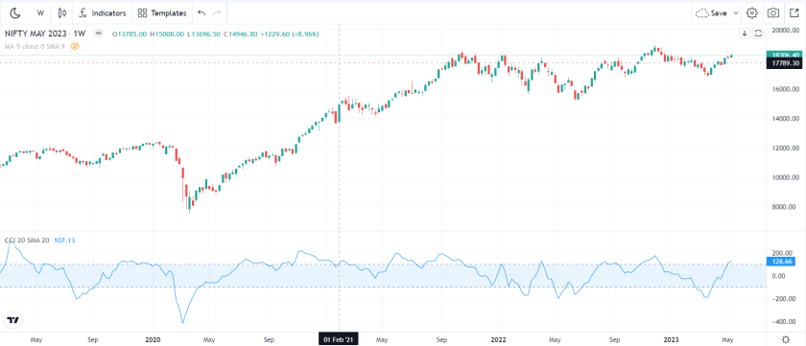

CCI or Commodity Channel Index is a leading technical indicator. Though the name starts with the word commodity, it has no direct relation with commodity trading. Rather this indicator is a very useful indicator for the trading of all assets/ stocks.

1. RSI or the Relative Strength Index

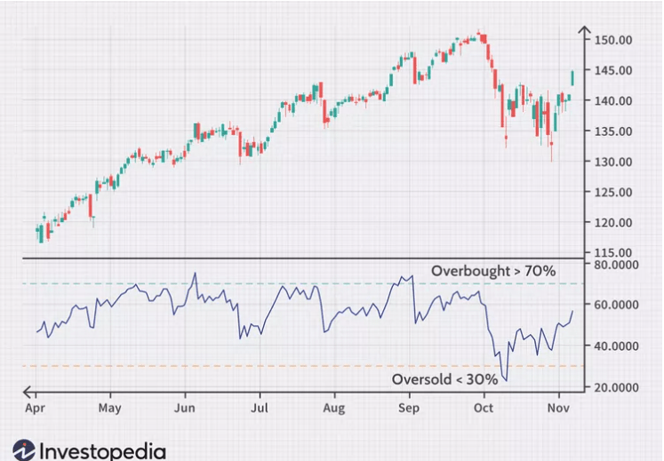

RSI or the Relative Strength Index is another highly popular leading technical indicator. RSI is a momentum indicator that shows the [overbought-oversold](https://www.stockmaniacs.net/overbought-and-oversold-meaning/) zones of price.

1. Volume

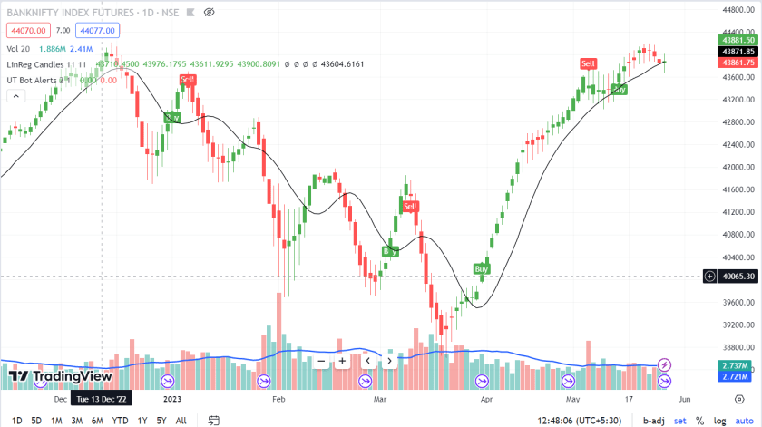

Volume is an important technical indicator. It is generally agreed that delivery with high volume indicates a surge in price. But this condition is not the only factor that controls the price direction

.

1. Lagging Indicator
2. [moving average](https://www.stockmaniacs.net/moving-average-indicator/)

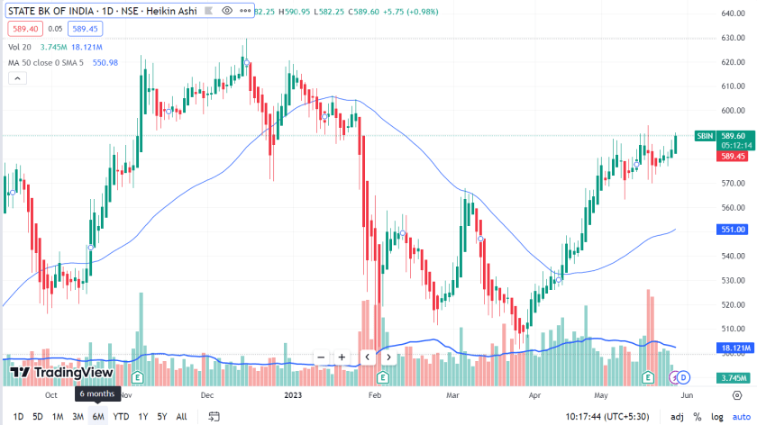

The Simple Moving Average (MA) is also known as MA. When the moving average shows the moving average of prices over every day, we call it the Daily Moving Average (DMA). MA is nothing but the average price of the stock or asset over a specific time. DMA is the daily moving average. The MA calculation counts the closing price of a stock over a specified period. The average price is of 14 periods as a standard. But we can customize it.

1. Moving average crossovers

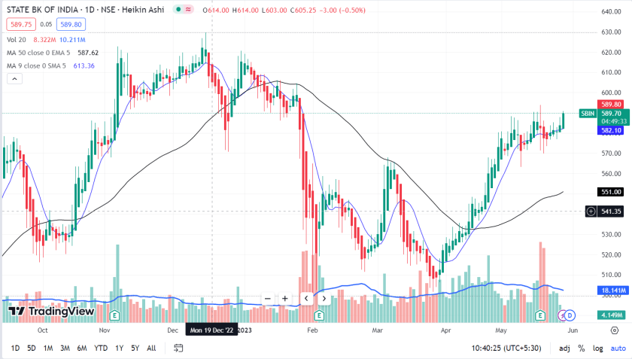

This is not an independent indicator. We consider two or more MAs or EMAs to compare the latest price trend. Traders consider 9 EMA and 50 EMA to get the latest trend. We sometimes take the crossover point of these two MAs to take buy or sell trade

1. Moving Average Convergence Divergence or MACD

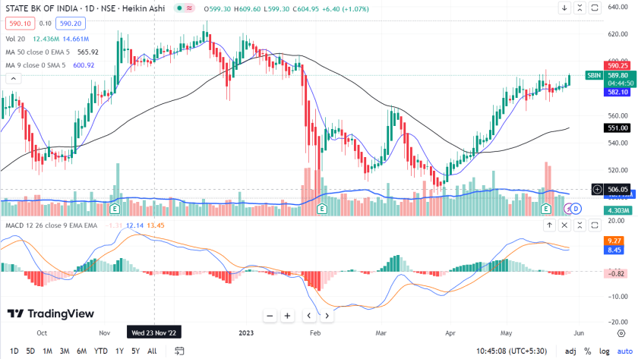

The Moving Average Convergence Divergence or MACD is a lagging indicator that uses MA to show the immediate trend. It helps the trader to take trading decisions. MACD shows momentum and trend strength which helps traders to take decisions. It uses two EMAs to plot fast and slow lines. MACD also provides a histogram to give a better view of trend duration

1. CONCLUSION

In conclusion, this comparative analysis sheds light on the efficacy of leading and lagging technical indicators in the Indian stock market context. Through meticulous examination and practical examples, this study has underscored the importance of understanding the nuances of these indicators in forecasting stock price movements. Both leading and lagging indicators exhibit strengths and weaknesses, with their utility contingent upon market conditions and investment strategies. While leading indicators offer early signals for potential trend reversals, they are prone to false positives, especially in volatile markets. On the other hand, lagging indicators provide more reliable signals by confirming established trends, albeit with a delay. The integration of multiple indicators and complementary analysis tools emerges as a prudent approach to enhance trading strategies. Ultimately, this research contributes valuable insights to traders and investors, empowering them to make informed decisions amidst the dynamic landscape of the Indian stock market.

1. FUTURE WORK
2. Algorithmic Trading and Machine Learning Integration:

Explore the integration of advanced machine learning techniques and algorithms to enhance the predictive power of technical indicators. Develop and test machine learning models that can adapt to changing market conditions and optimize trading strategies based on real-time data.

1. Dynamic Indicator Parameters:

Investigate the dynamic adjustment of indicator parameters based on market volatility, trend strength, or other relevant factors. This adaptive approach could potentially improve the robustness of indicators across various market conditions.

1. Cryptocurrency Markets Analysis:

Extend the research to analyze the effectiveness of leading and lagging indicators in cryptocurrency markets. Given the unique characteristics and volatility of cryptocurrencies, understanding how these indicators perform in this emerging market could be valuable.

1. Real-Time Monitoring and Alerts:

Develop tools for real-time monitoring of indicators and automated alert systems. This could assist traders in making timely decisions by receiving alerts for potential buy or sell signals based on the analyzed technical indicators.

1. Behavioral Finance Considerations:

Explore the impact of behavioral biases on the effectiveness of technical indicators. Investigate how investor sentiment, cognitive biases, and herd behavior influence the signals generated by leading and lagging indicators.

1. Intraday Trading Analysis:

Narrow the focus to intraday trading and assess the performance of technical indicators on shorter timeframes. Understand how well these indicators adapt to the rapid price movements and short-term trends characteristic of intraday trading.

1. Portfolio Management Strategies:

Extend the research to evaluate how the combination of leading and lagging indicators can contribute to effective portfolio management. Assess the diversification benefits and risk-adjusted returns achieved by incorporating a variety of technical indicators.

1. Cross-Market Comparison:

Conduct a comparative analysis of leading and lagging indicators across different global markets. Explore whether the effectiveness of these indicators varies based on regional economic conditions, market structures, or regulatory environments.

1. Interactive User Interfaces:

Develop user-friendly interfaces or tools that allow traders and investors to interactively explore and customize the application of technical indicators. This could facilitate a more personalized approach to technical analysis.

ACKNOWLEDGMENT

The successful realization of the "Comparative Analysis of Leading and Lagging Technical Indicators in the Indian Stock Market" project owes much to the generous support and collaboration of numerous individuals and institutions. We express profound gratitude to our sponsors whose visionary support provided the foundational resources and encouragement essential for this research's development, contributing significantly to shaping its vision and methodology. Special appreciation is extended to Mrs. Pranjali Kasture for her invaluable guidance, mentorship, and expertise, which played a pivotal role in steering the research towards success. Her insightful feedback and unwavering encouragement were instrumental in refining our approach and ensuring the quality of our analysis. Furthermore, we acknowledge Thakur College of Engineering and Technology for providing the conducive academic environment and resources that facilitated the research and development process, reflecting the institution's commitment to fostering excellence in education and research. Lastly, we extend our thanks to all individuals who directly or indirectly contributed to this project's realization, as your support has been invaluable in bringing this research to fruition.

REFERENCES

[1] Gupta, R., et al. (2019). A Comparative Analysis of Moving Averages and Relative Strength Index (RSI) in Stock Market Trading. International Journal of Management, Technology, and Engineering, 9(1), 2229-3191.

[2] Sharma, S., & Jain, R. (2018). Predictive Power of Stochastic Oscillator in Indian Stock Market. International Journal of Recent Technology and Engineering, 8(2), 209-213.

[3] Goyal, N., & Arora, A. (2020). Predicting Stock Prices using Machine Learning Techniques. International Journal of Recent Technology and Engineering, 8(4), 8235-8241.

[4] Agarwal, S., et al. (2017). Predicting Stock Prices using Machine Learning Techniques. International Journal of Computer Applications, 160(2), 19-24.

[5] Mishra, S., et al. (2016). A Comparative Study of Technical Indicators in Stock Market for Generating Trading Signals. International Journal of Scientific Research in Computer Science, Engineering, and Information Technology, 2(5), 27-32.

[6] Singh, R., & Sharma, S. (2017). A Comparative Study of Technical Indicators in Stock Market for Generating Trading Signals. International Journal of Engineering Science, 6(11), 54-58.

**4.3 Rubrics**

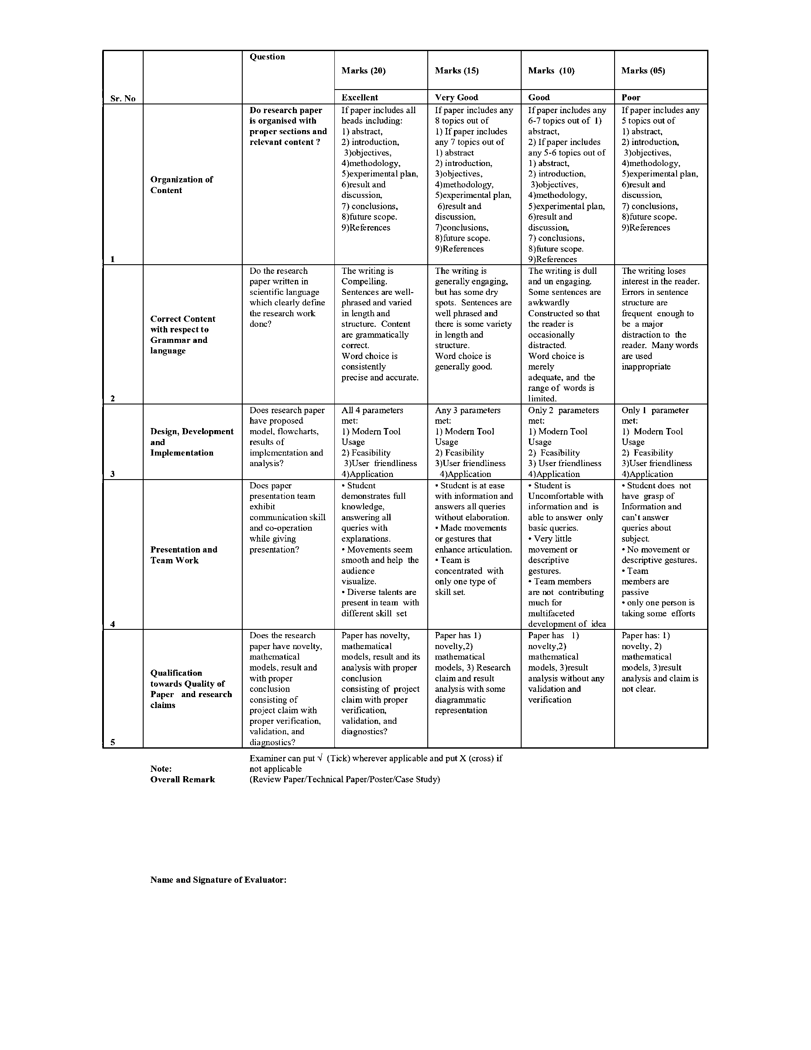

**Chapter 5. Outside Participation certificates**

**5.1 Certificate (Screenshot)**

**Pranav Bhavsar**





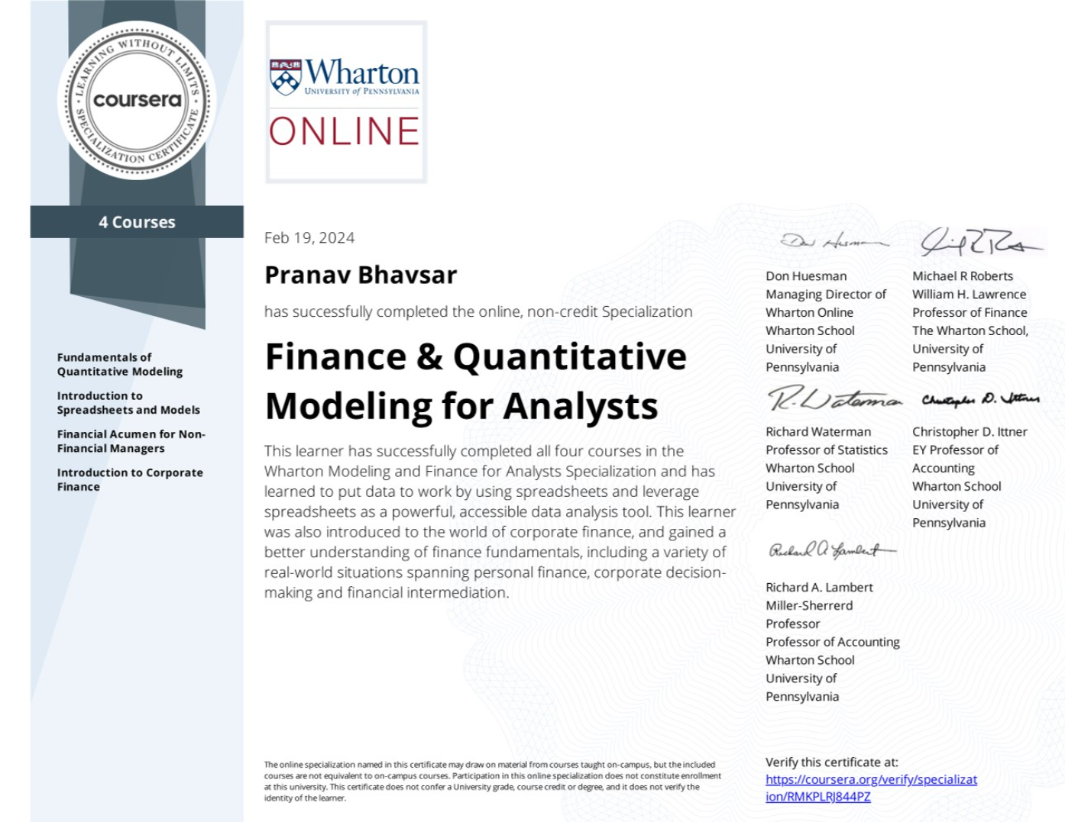





**Bharat Bohra**





**5.2 Rubrics**

|  |  |  |  |  |
| --- | --- | --- | --- | --- |
| **Parameter** | **Excellent**  **(20 Marks)**  **100 %** | **Very Good**  **(15 Marks)**  **75 %** | **Good**  **(10 Marks)**  **50 %** | **Average**  **(05 Marks)**  **25 %** |
| Problem Identification  GA 2 | Insightful and in-depth background information is provided to illuminate the issues through inclusion of:  • history relevant to the presentation, the “big picture”  • a succinct description of the significance of the project | Background information is provided, including references to the work of others and an explanation of why the project was undertaken, to help put the presentation in context. | Little background information is presented using relevant references to help the audience understand the history and significance of the project. | Very little or no background information is presented to help the audience understand the history and significance of the project. |
| Content  GA 4 | • Addresses all specified content areas.  • Material abundantly supports the topic.  • Use of engineering terms and jargon matches audience knowledge level. | • Addresses most content areas.  • Material sufficiently supports the topic.  • Use of engineering terms and jargon mostly matches audience knowledge level. | • Addresses some of the content areas.  • Material minimally supports the topic.  • Use of engineering terms and jargon minimally matches audience knowledge level. | • Addresses few of the content areas. • Material does not support the topic.  • Use of engineering terms and jargon does not match audience knowledge level. |
| Visuals  GA4,GA5 | • Use of prezi or advance tools  Text is easily readable.  • Graphics use constantly supports the presentation.  • Slide composition has a professional look that enhances the presentation | •Use of Powerpoint presentation  Text is readable. • Graphics use mostly supports the presentation. • Slide composition is not visually appealing, but does not detract from the presentation | • Text is readable with effort.  • Graphics use rarely supports the presentation. • Slide composition sometimes distracts from the presentation | • Text is not readable.  • Graphics use does not support the presentation. • Slide composition format is clearly distracting, obscuring the presentation |
| Presentation Skills  GA 7 | • Clearly heard and polished.  • Attitude indicates confidence and enthusiasm.  • Audience attention is constantly maintained. | • Clearly heard but not polished. • Attitude indicates confidence but not enthusiasm.  • Audience attention is mostly maintained. | • Difficult to hear and/or moments of awkwardness. • Attitude indicates some lack of confidence and/or disinterest in subject.  • Audience attention is minimally maintained | • Inaudible; several awkward pauses.  • Attitude indicates lack of confidence and/or disinterest in subject.  • Audience attention is not maintained |
| Participation level  GA 12 | International / National | State | District / Local | Institute |